**Project Initialization and Planning Phase**

| Date | 10 July, 2024 |
| --- | --- |
| Team ID | SWTID1720173354 |
| Project Name | Gemini Health Application |
| Maximum Marks | 3 Marks |

**Define Problem Statements (Customer Problem Statement Template):**

Nutritionist AI is a mobile application that serves as a virtual nutritionist, providing users with personalized advice on how to achieve their health and wellness objectives using data-driven nutritional suggestions.

Develop a mobile application, Nutritionist AI, that leverages advanced AI capabilities (Gemini Pro model) to provide personalized dietary recommendations and nutritional advice for users with various health and wellness goals.

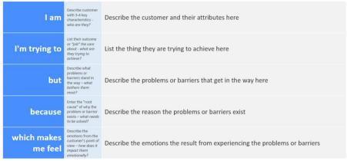

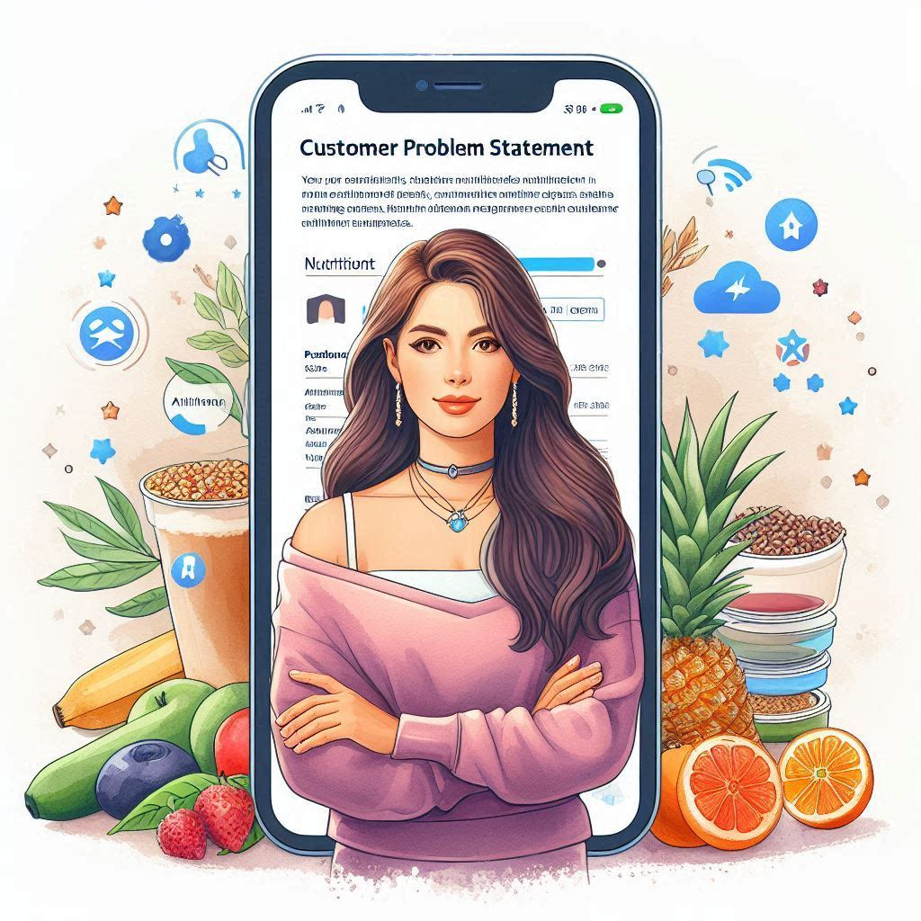

**Example:**

|  |  |  |  |  |  |
| --- | --- | --- | --- | --- | --- |
| **Problem**  **Statement (PS)** | **I am**  **(Customer)** | **I’m trying to** | **But** | **Because** | **Which makes me feel** |
| PS - 1 | A busy working professional with irregular eating habits. | Maintain a healthy weight and improve my energy levels. | I struggle to find time for meal planning and cooking nutritious meals. | My demanding work schedule leaves little room for proper nutrition. | Stressed and fatigued. |
| PS - 2 | A new parent juggling childcare responsibilities | Lose post-pregnancy weight and regain fitness. | Lack of sleep and time constraints hinder my ability to focus on healthy eating. | Caring for my baby leaves me exhausted and overwhelmed. | Frustrated and physically drained. |
| PS - 3 | A college student with a tight budget. | Improve my overall health and avoid the “freshman 15.” | Affordable food options often lack nutritional value. | Limited funds restrict my access to fresh produce and balanced meals. | Worried about my long-term well-being. |
| PS - 4 | A retiree dealing with age-related health challenges. | Manage my blood pressure and cholesterol levels. | Understanding dietary guidelines and making suitable food choices is confusing. | My health conditions require specific nutritional adjustments. | Anxious about my health outcomes. |
| PS - 5 | An athlete training for a marathon. | Optimize my performance and recovery. | Balancing macronutrients and hydration are complex. | Intense workouts demand precise nutritional support. | Determined but overwhelmed by the science of nutrition. |